In every newsletter we go over important parts of an insurance policy. Inflation factor: Home insurance policyholders are effected by the rate of inflation in many ways. This is driven by the inflation of labor, repair costs and the continued rising costs of construction materials. The inflation factor is to assist in keeping insured values of these structures at adequate limits. Your home insurance company will likely automatically adjust your coverage amount at each renewal in order to keep up with rising costs.
Full glass coverage: Full glass coverage is a policy add-on that covers windshield repair and repairs for other window damage- does not cover mirrors on most policies. Full glass coverage does not have any deductible. You get a new window without having to pay anything. Do I really need it? Do you drive on roads with gravel or meet a lot of trucks. Do you live in an area where break-ins are common? The decision is-do I pay a slightly higher premium for this coverage eliminating your out of pocket costs for common glass repairs.
_________________________________________

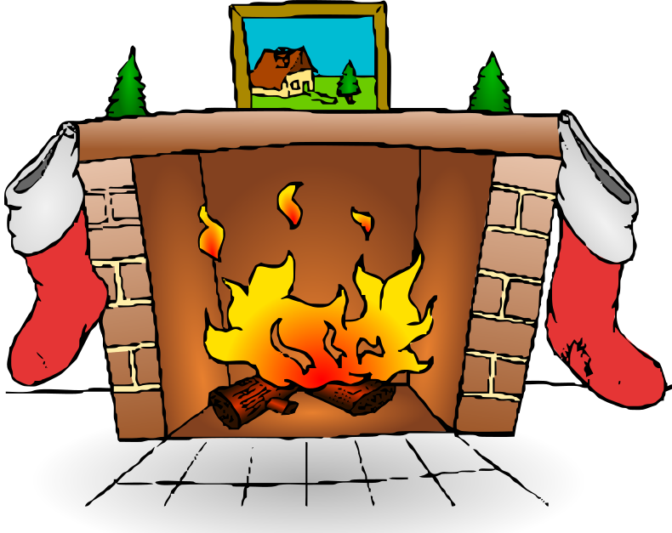 AHH-a warm fire, good food, a good book and all the comforts of home after a long day. Sounds wonderful doesn’t it? There is an old saying about warming your hearth or burning down your house you never can tell. Just a few tips for managing the risk: 1. Don’t burn trash –most fireplaces and woodstoves are not designed to withstand the high heat generated by paper. 2. Never leave a fireplace unattended. 3. Burn dry, seasoned wood. 4. Check monthly and clean when creosote begins to accumulate. 5. Ashes should be placed in a metal container with a tight fitting cover. 6. Hot or warm ashes should be kept outside away from the dwelling to cool.
End of Year Reminder For Crop Insurance: Production reports need to be returned and signed so we can determine your 2022 guarantee.
MARK YOUR CALENDAR! Dec 4th is National Cookie Day. The cookie is one of our favorite desserts. Cookies were invented during the seventh century in Persia. That was when sugar became a common resource in that region. The cookie spread through Europe and marched across the continent until it became one of the most common snack foods in Europe by the fifteenth century. It made its way across the Atlantic into the Americas via the Dutch settlers. Colonial housewives snatched up the cookie and began making their own.

MANAGERS COMMENTS The year and time seem to go by faster every year. Looking ahead into next year- look not only at price increases on commodities and goods but shortages as well. My companies advised me they totaled more cars this year due to the fact they could not get parts. All indications show more shortages and high prices for parts due to shipping charges. Look for rate increases in insurance as well.
We want to thank you for the past years support and we wish you and your family a Merry Christmas and Blessed New Year from all of our staff!

Christmas is a necessity. There has to be at least one day of the year to remind us that we’re here for something else besides ourselves. By Eric Sevareid MERRY CHRISTMAS KEVIN, PATTY, EVETTE, LINDA, MORGAN and MICHAEL
FIRST STATE INSURANCE AGENCY IS AN EQUAL OPPORTUNITY PROVIDER.

